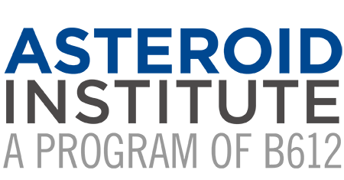

B612 Foundation Announces New Board Chair, Futurist Peter Schwartz

San Francisco, February 1, 2022 /PRNewswire/ — B612 Foundation, the well-respected non-profit organization dedicated to protecting Earth from asteroid impacts, has announced the election of Peter Schwartz as Chair of its Board of Directors.
Peter Schwartz succeeds venture capitalist David Liddle as Chair of B612 Foundation, who provided seven years of strong and experienced leadership.
“It is with deep appreciation and sadness that we accepted David Liddle’s retirement,” said B612 President Danica Remy. “David steered us through the launch of the Asteroid Institute, our Fellow research program, and most importantly the work to launch our Asteroid Discovery Analysis and Mapping platform (ADAM). His kind spirit, strategic insight, and his vast experience contextualized our decisions for the path forward.”
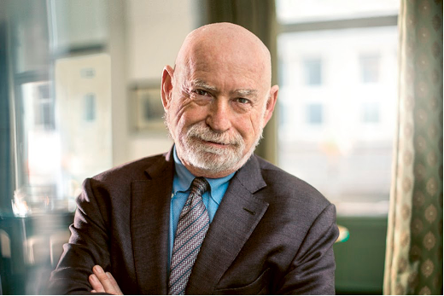
Peter Schwartz is an internationally renowned futurist and business strategist, specializing in scenario-planning and working with corporations, governments, and institutions to create alternative perspectives of the future and develop robust strategies for a changing and uncertain world. Peter serves as Senior Vice President of Strategic Planning for Salesforce, managing the organization’s ongoing strategic conversation. Prior to joining Salesforce, he was co-founder and chair of Global Business Network.
“Peter brings a unique combination of passion for space, the advancement of technology for the good of humanity and a keen ability to frame the future,” said Danica Remy, President, B612 Foundation. “I am excited to have Peter Schwartz lead our board as he has spent decades studying and advocating long-term strategic thinking — and planetary defense is the ultimate example of thinking for the long term,” said Asteroid Institute Executive Director and three-time NASA astronaut, Dr. Edward Lu.
“I look forward to advocating and realizing B612 Foundation’s mission to find asteroids which could potentially impact Earth, so that we can then use techniques, such as the Gravity Tractor, invented by Dr. Lu, and other techniques to gently move them away from a collision course with our planet and protect all that we find precious on this Earth,” said Schwartz.
Peter Schwartz is the author of several publications. His first book, The Art of the Long View, is considered a seminal publication on scenario planning. Additionally, he has served as a script consultant on the films Minority Report, Deep Impact, Sneakers, and War Games. Peter earned a Bachelor of Science in aeronautical engineering and astronautics from Rensselaer Polytechnic Institute in New York.

About B612 Foundation
B612, and its primary program, the Asteroid Institute, works towards protecting the Earth from asteroid impacts and informing worldwide decision-making on planetary defense issues. The organization provides a non-governmental voice on the risks, options, and implications of asteroid data while advancing the technical means by which that data is acquired. It works to make interpretation of asteroid data open and accessible, and the organization serves as an informed source for an international community of policymakers and scientists who can best help to achieve these goals. To learn more about the B612 Foundation, donate, or become a member, visit: www.B612foundation.org
Contact: Danica Remy, President, danica.remy@b612foundation.org

