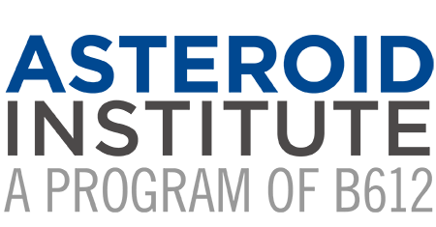

Asteroid Institute Uses Revolutionary Cloud-Based Astrodynamics Platform to Discover and Track Asteroids

FACT SHEET

Technical Information
What is the “title” announcement about in a nutshell?
How does the astronomical community track asteroid discoveries?
Are any of the asteroids discovered by the Asteroid Institute a danger of hitting the Earth?
What is the Asteroid Discovery Analysis and Mapping (ADAM) platform?
What is Tracklet-less Heliocentric Orbit Recovery (THOR)?
What is ADAM::THOR?
What is next for ADAM::THOR?
What is the relationship between University of Washington’s DiRAC and Asteroid Institute?
What is the difference between identifying asteroids in images and making an asteroid discovery?
How are these methods different from recent identifications of asteroids in Hubble images?
How are asteroids found and tracked?
How is Asteroid Institute’s approach different from other approaches being used?
How are the asteroid orbits visualized in the video?
What is Google Cloud’s role in the Asteroid Institutes research?
Why did Google Cloud decide to support this endeavor?
Is Google’s Artificial Intelligence being used by the ADAM platform?
Why is a comprehensive map of the solar system needed?
How does this work relate to what NASA is doing?
Is this work different from what is being done at NASA?

Spokespeople* and Available Quotes
* Dr. Ed Lu, Asteroid Institute Executive Director
* Joachim Moeyens, co-creator of THOR, Asteroid Institute Fellow
* Dr. Mario Juric, co-creator of THOR, Director UW DiRAC Institute
* Scott Penberthy, Director of Applied AI at Google
* Danica Remy, President, B612 Foundation, Co-Founder Asteroid Day
Rusty Schweickart, Apollo 9 Astronaut and B612 Foundation Co-Founder (retired)
Dr. Matt Holman, Senior Astrophysicist, Harvard | Smithsonian Center for Astrophysics
Vint Cerf, Chief Internet Evangelist, Google
David Brin, scientist, speaker, technical consultant and world-known author
Scott Manley, Online Science Communicator or ‘Internet rocket scientist’
Massimo Mascaro, Distinguished Technical Director, Applied AI, Google Cloud

About
Asteroid Institute – a program of B612 Foundation
Partners and Funders
Leadership

Terms and Acronyms Defined

Technical Information

What is the “title” announcement about in a nutshell?
We’re reporting on the first discoveries from a novel computational technique that is able to find asteroids in any astronomical imaging dataset, and not just those specifically taken to enable asteroid searches. The IAU Minor Planet Center has added these to its asteroid registry. This new technique opens the door to dramatically expanding the range of datasets available to astronomers to explore the Solar System, and for Asteroid Institute researchers and collaborators to find and report many thousands of new asteroid discoveries.
The computational technique used to discover these asteroids is called Tracklet-less Heliocentric Orbit Recovery (THOR), described in a 2021 Astronomical Journal paper by Asteroid Institute/UW researchers Joachim Moeyens, Mario Juric, and collaborators. It was run on our open-source Asteroid Discovery Analysis and Mapping (ADAM) platform running on Google Cloud. A short video explaining this news can be found here.

How does the astronomical community track asteroid discoveries?
Short Answer
The Minor Planet Center is the official clearinghouse for asteroid observations and is used by astronomers worldwide as the definitive registry for asteroid discoveries.
Long Answer
The Minor Planet Center is the official clearinghouse for asteroid observations and is used by astronomers worldwide as the definitive registry for asteroid discoveries. To be added to the asteroid database requires not only that an asteroid is observed once, but that it has a sufficient number of observations for its orbit to be determined. Our algorithm, THOR, is uniquely able to link observations taken at nearly arbitrary times as belonging to the same object, allowing us to determine its orbit and have it officially recognized and cataloged.

Are any of the asteroids discovered by the Asteroid Institute a danger of hitting the Earth?
No, none of the asteroids we discovered so far have orbits that come close to the Earth (so-called Near Earth Objects; NEOs). They are not a danger of hitting Earth. They tend to be located in the Main Belt, which is between the orbits of Mars and Jupiter.
The present version of THOR focuses on high-efficiency searches for asteroids in the Main Asteroid Belt and the Outer Solar System. We are developing the capability to detect NEOs with similar efficiency.

What is the Asteroid Discovery Analysis and Mapping (ADAM) platform?
Short Answer
ADAM (https://adam.b612.ai) is an Asteroid Institute-developed and operated open-source cloud-based scalable platform for running computationally demanding astrodynamics algorithms. Astrodynamics is the science of the motion of astronomical bodies moving under the influence of gravity, and allows us to understand the orbits of planets and asteroids in our solar system. By being open-source, these calculations can be easily verified, built upon, and shared with others in the scientific community.
Long Answer
ADAM (https://adam.b612.ai) is an open-source cloud-based platform providing astrodynamics as a service. By hosting a range of astrodynamics algorithms, ADAM allows users to run orbital analyses, including asteroid discovery.
ADAM uses Google Compute Engine to perform these calculations at scale, enabling the calculation and analysis of millions of orbits or searching for new objects in billions of observations.
ADAM’s architecture consists of a web-service front-end, Application Programming Interfaces (APIs), cloud-based storage, and cloud-based compute engines. A short video explaining this news can be found here.

What is Tracklet-less Heliocentric Orbit Recovery (THOR)?
Short Answer
THOR stands for “Tracklet-less Heliocentric Orbit Recovery”. It is the name of a unique, novel, algorithm, developed by Asteroid Institute-supported scientists at the University of Washington’s DiRAC Institute, that enables researchers to discover asteroids without a need for tracklets (two or more intra-night detections) which the current state-of-the-art algorithms have to rely on. More on intra-nightly detections below.
Long Answer
Present-day asteroid discovery relies on the telescope taking multiple images of the same area of the sky each night. These images allow the object to be detected as moving, estimate its rate of motion, and connect – “link” – it to similar repeated observations in subsequent nights. Unfortunately, this requirement for intra-night re-observations makes it impossible to use datasets not observed with such cadence – the vast majority of astronomical datasets – for asteroid discovery. Our THOR algorithm removes this constraint, and enables astronomers to find asteroids in astronomical images taken with nearly arbitrary cadence, as long as there are enough observations to uniquely determine an asteroid’s orbit (about 5 in a
30-day window). It does this by efficient sampling and searching of the orbital parameter space, leveraging the computational power and scalability of modern computing platforms.

What is ADAM::THOR?
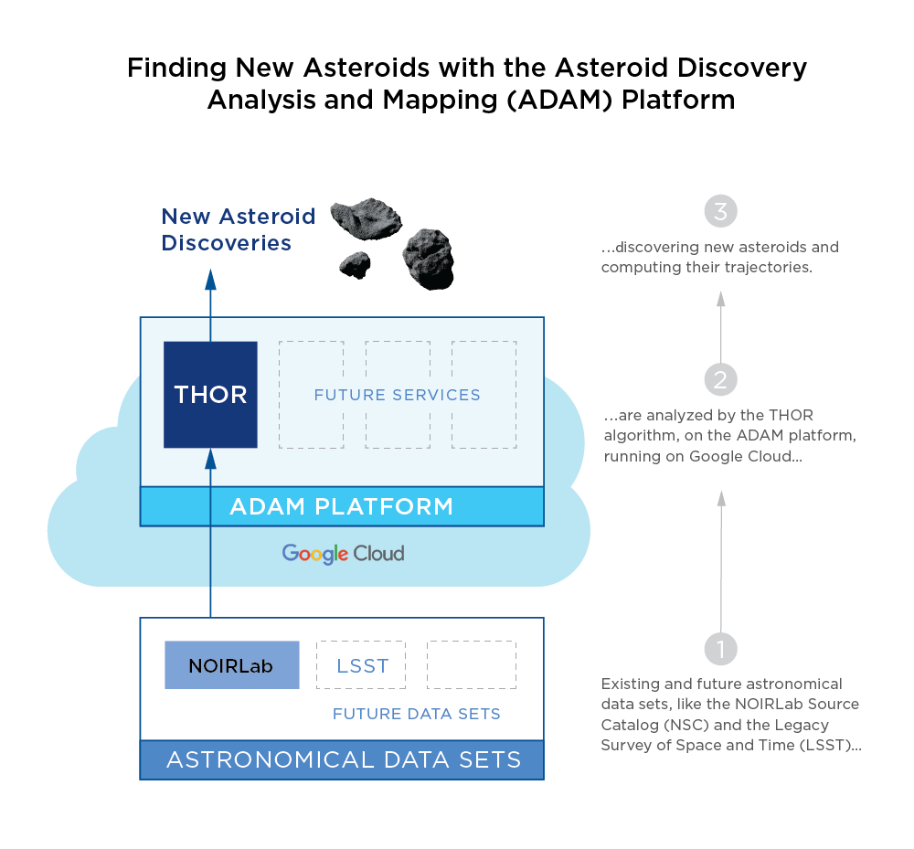
Short Answer
The THOR algorithm, while enabling the discovery of asteroids that where not previously possible, requires significant computational resources. ADAM::THOR, uses Google Cloud’s computational power to make discoveries of new asteroids and the determination of their orbits feasible in practice.

Long Answer
ADAM::THOR is an implementation of THOR running on the scalable ADAM platform. It opens the possibility of utilizing data collected by any telescope in the world for asteroid discovery. It makes it possible to search through years of archival data for previously missed objects. It will open up the possibility of increasing the productivity of special-purpose asteroid search telescopes by allowing them to free up their observing patterns and monitor more of the sky each night.
Present-day asteroid discovery and orbit determination generally require telescopes to observe the sky with a specialized cadence: a pattern of observations in space and time. Usually, telescopes will revisit the same area of the night sky three or four times to detect a sequence of observations of the same asteroid – a tracklet. Prior to THOR, only dedicated asteroid search programs could effectively find asteroids, while the majority of data collected by other telescopes could not be used.
THOR can discover objects without the need for tracklets to be observed. Rather, it can link observations at nearly arbitrary cadences within a linking window, as long as there’s enough data to determine an orbit (usually 5-6 observations in a 15-30 day window). Removing the requirement for tracklets to be observed enables the discovery of minor planets in telescopic data sets that were not typically suited for Solar System discovery (i.e. the vast majority of datasets).
This functionality requires significant computational resources. ADAM::THOR allows researchers and scientists to utilize Google Cloud’s computational power to make these discoveries. This adds asteroid discovery to the list of ADAM capabilities.

What is next for ADAM::THOR?
The discoveries announced today were made while searching only a small fraction – less than 0.5% – of the NOIRLab dataset. They demonstrate the power and the utility of the new technique and cloud-based system. Asteroid Institute researchers are already hard at work searching the rest of the NOIRLab data set for asteroids as well as looking at mining other datasets. With ADAM::THOR, we expect to discover and contribute orbits for tens of thousands of previously missed objects.

What is the relationship between University of Washington’s DiRAC and Asteroid Institute?
B612 Foundation, a 501c3 nonprofit organization, runs the Asteroid Institute. DiRAC is an interdisciplinary institute at the University of Washington whose researchers work to understand the universe through the development and application of advanced algorithms. The B612 Foundation funds Postdoctoral and Graduate Student Fellows at the UW DiRAC Institute to work on asteroid-related research. The two programs, Asteroid Institute and DiRAC Institute work together as research collaborators.

What is the difference between identifying asteroids in images and making an asteroid discovery?
Short Answer
Calculating the orbit of an asteroid requires that it be observed multiple times over a long enough period of time that we can be confident we know where that asteroid will be in the future as well as where it was in the past. Thus, if that asteroid is observed again in the future, we can know that it is one that we have already discovered because its orbit will match. This orbit (and thus the future location) of an asteroid is required if we wish to obtain further detailed observations, if we wish to send a spacecraft there, or if we want to determine the chance of that asteroid hitting Earth.
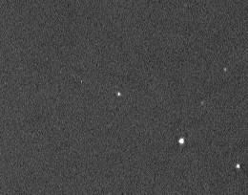
Long Answer
An asteroid can be identified in a sequence of closely spaced images by its motion (see the animation to the right, from the Spaceguard Centre; notice how the speck of light in the center appears to move). But such a short “tracklet” of observations isn’t sufficient to unambiguously compute where this asteroid will be tomorrow, in a month, or in a year. For an asteroid to be considered discovered, we need to know that we can predict where it will be at times into the future. It needs to be observed enough times for its long-term trajectory – the orbit – to be computed.

How are these methods different from recent identifications of asteroids in Hubble images?
We applaud the recent identification of asteroid trails in Hubble Space Telescope images carried out through citizen science. The work that we are reporting on here is a step beyond identification. We link together enough observations to calculate the orbits of asteroids well enough for them to be considered “discovered” and added to MPC orbit databases. The asteroids identified in the Hubble images could at some point be used by ADAM::THOR to be linked to other observations so that the necessary orbits can be calculated.

How are asteroids found and tracked?
Astronomers (amateur and professional) take images of asteroids using telescopes around the world. They measure their positions and brightness, and report these observations to the International Astronomical Union’s Minor Planet Center (the MPC).
For it to be considered discovered, an asteroid needs to be observed enough times so that an orbit can be determined. It usually takes observations spread out over a week to a month to establish a sufficiently good orbit determination. At present, these observations typically include closely-spaced re-observations called “tracklets”. THOR relaxes that requirement.

How is Asteroid Institute’s approach different from other approaches being used?
Observers find and track asteroids using telescopes around the world. The discovery of an asteroid requires that it be observed enough times so that an orbit can be determined. It usually takes observations spread out over a week to a month to establish a good orbit determination. At present, these typically include closely-spaced observations called tracklets.
In partnership with the University of Washington’s DiRAC Institute, the Asteroid Institute funded the development of the open-source THOR (Tracket-less Heliocentric Orbit Recovery) algorithm. THOR – combined with the high-performance and scalability of cloud computing – makes it possible to discover asteroids without the need for tracklets. The Institute has now adopted the algorithm as the “discovery” component that runs on the ADAM platform.

How are the asteroid orbits visualized in the video?
In this video, we show the orbits of the first 104 asteroids discovered using THOR. The visualization was done using the open source astrodynamics package called Open Space.

What is Google Cloud’s role in the Asteroid Institutes research?
The Asteroid Institute is using a new computational technique running on its Asteroid Discovery Analysis and Mapping (ADAM) cloud-based astrodynamics platform to discover asteroids. The ADAM platform is an open-source computational system that runs astrodynamics algorithms at a large scale using Google Cloud, including the scalable computational and storage capabilities in Google Compute Engine, Google Cloud Storage and Google Kubernetes Engine.
In 2019 and 2020, the Google Cloud’s Office of the CTO conducted architectural sessions and organized hackathons with solution architects at Google Cloud to find the best way to implement ADAM on Google Cloud at scale. Google Cloud has also provided Cloud credits and technical support for the ADAM platform’s current development and future work.

Why did Google Cloud decide to support this endeavor?
Google has always been interested in the application of Cloud technology that enhances humanity at large and showcases how the public cloud can be a force of good and innovation. Google believes that B612 and the work of their Asteroid Institute project ADAM had a great use case.

Is Google’s Artificial Intelligence being used by the ADAM platform?
AI is a powerful tool to analyze data where no good physical model exists (i.e. is this a picture of a cat?) and where millions of examples can be used to train the AI algorithms. The situation with asteroid discovery is the opposite. We have an extraordinarily accurate physical model (i.e., we understand the laws of orbital mechanics), and we do not have millions of examples for training. Thus asteroid discovery and orbit determination are currently a poor choice for using AI. This may change though, as new telescopes and sensors come online.

Why is a comprehensive map of the solar system needed?
Short Answer
Knowing the location and orbital trajectories of the bodies in our solar system is required to protect the Earth from asteroid impacts, critical for understanding the origin and evolution of the solar system, and potentially key to the economic development of space. However, a modern map is not simply a database of objects and orbits. Equally important is the suite of tools and services that allow analyses to be easily carried out, results shared, and additional location-based services to be built upon that database. The ADAM platform being developed by the Asteroid Institute is an open-source platform that, together with data from current and new observatories like the Vera Rubin Observatory, will form the basis of that future solar system map.
Long Answer
Throughout human history, mapping has been the key to the opening of new frontiers. Mapping of new frontiers enabled economic expansion and scientific understanding. The Asteroid Institute is committed to creating a platform that can map the locations and trajectories of the millions of uncharted asteroids in our solar system.
Knowing the location and orbital trajectories of the bodies in our solar system is obviously required to protect the Earth from asteroid impacts, critical for understanding the origin and evolution of the solar system, and potentially key to the economic development of space. However, a modern map is not simply a database of objects and orbits. Equally important is the suite of tools and services that allow analyses to be easily carried out, results shared, and additional location-based services to be built upon that database. The ADAM platform being developed by the Asteroid Institute is an open-source platform that, together with data from current and new observatories like the Vera Rubin Observatory, will form the basis of that future solar system map.

How does this work relate to what NASA is doing?
Both NASA and the Asteroid Institute are part of the worldwide community of astronomers working to find and track asteroids, not only for their scientific and potential commercial importance but also because sometimes these asteroids do hit the Earth. NASA has an active program of asteroid discovery, funding astronomers at a number of observatories. Private donors have supported the Asteroid Institute and its work.

Is this work different from what is being done at NASA?
NASA supports a wide range of space science work, including efforts to discover and track asteroids. However, the open-source ADAM platform and the results being reported on here by the Asteroid Institute were privately funded.

Spokespeople* and Available Quotes

Individuals with an * next to their names are available for media interviews as it relates to this asteroid discovery press release. Please contact fill out our media request form here, and a member of our team will reach back to discuss scheduling a call for your outlet.

* Dr. Ed Lu, Asteroid Institute Executive Director
“Discovering and tracking asteroids is crucial to understanding our solar system, enabling the development of space, and protecting our planet from asteroid impacts. With ADAM::THOR, any telescope with an archive can now become an asteroid search telescope”
“We are using the power of massive computation to enable not only more discoveries from existing telescopes, but also to find and track asteroids in historical images of the sky that had gone previously unnoticed because they were never intended for asteroid searches.”

* Joachim Moeyens, co-creator of THOR, Asteroid Institute Fellow
“The Asteroid Institute’s ADAM platform is perfectly suited for the THOR algorithm. Built on Google Cloud, ADAM’s innate scalability and computational power allows us to fully maximize THOR’s potential as a discovery algorithm and ultimately allows us to find those asteroids that have thus far remained undetected in archival datasets. The potential of this software ecosystem also stretches far beyond historical data – with additional development, ADAM::THOR will be able to perform real-time asteroid discovery on observations as they come in from telescopes around the globe.”

* Dr. Mario Juric, co-creator of THOR, Director UW DiRAC Institute
“The work of the Asteroid Institute is critical because astronomers are reaching the limits of what’s discoverable with current techniques and telescopes. Our team is pleased to work alongside the Asteroid Institute to enable mapping of the solar system using Google Cloud.”

* Scott Penberthy, Director of Applied AI at Google
“We always dreamed of cloud computing becoming a true tool of science and the announcement of today’s and future asteroid discoveries show that this dream is becoming a reality.”
“Scalable cloud-computing as a service is enabling true breakthroughs in astronomy, just as it has for other scientific areas including biology and physics. I couldn’t be more proud of our partnership with B612 and what we’ve been able to accomplish together.”

* Danica Remy, President, B612 Foundation, Co-Founder Asteroid Day
“We are humbled and inspired by the generosity of our funding partners. Their support over the years and into the future, along with Tito’s matching challenge, is helping us scale our technical team and expand our scientific, technical, and educational partnerships,”
“The Foundation has a three-year funding goal to raise a further $4 million to advance the Asteroid Discovery Analysis and Mapping (ADAM) platform. These funds will enable ADAM to analyze historical data and future data coming from Vera Rubin Observatory and its Legacy Survey of Space and Time (LSST), which will enable new asteroids’ discoveries and orbits.”

Rusty Schweickart, Apollo 9 Astronaut and B612 Foundation Co-Founder (retired)
“In the really big picture we human beings, and all other life here on Earth, will slowly emerge from our planetary womb to begin exploring and populating the local cosmic environment. In partnership with the tools we create, we both enable our exploration capabilities and enhance our survival probabilities. We have no real sense of the ultimate possibilities that will emerge in our evolutionary future. We do know, however, that there are existential threats inherent in this scenario, one being asteroid impacts. It is both amazing and personally rewarding to see humanity beginning to assume the responsibility to intelligently modify the clockwork of the solar system to facilitate this exciting future.”

Dr. Matt Holman, Senior Astrophysicist, Harvard | Smithsonian Center for Astrophysics
“A comprehensive map of the Solar System gives astronomers critical insights both for science and planetary defense. Tracklet-less algorithms such as THOR greatly expand the kinds of datasets astronomers can use in building such a map.”

Vint Cerf, Chief Internet Evangelist, Google
“The Asteroid Discovery Analysis and Mapping (ADAM) platform is another great example of what cloud technology makes possible. You couldn’t learn about all these asteroids and their movement through space without having significant amounts of computation at your disposal. It’s an exciting new tool for mankind. There are a lot of problems in this world that we can’t solve, but technologies that capture and analyze huge data sets is increasingly opening doors that were previously shut. It gives me hope and optimism that by combining human ingenuity, data and large scale computation, we’ll be able to enhance humanity’s prospects and do a lot of good.”

David Brin, scientist, speaker, technical consultant and world-known author
“B612 has led the way, educating world citizens to the dangers of asteroidal impacts, spurring national and international programs to appraise the threat and find solutions. Now, those mighty new survey instruments are gushing tsunamis of data about the solar system. With this work of the Asteroid Institute, they enter a new phase, developing clever ways to sift through it all, finding the glittering rocks out there that might present either danger or opportunity,”

Scott Manley, Online Science Communicator or ‘Internet rocket scientist’
“B612 has always been focused on the Earth’s unseen neighbors in the solar system. The ADAM platform capabilities will show that in addition to processing the data stream from new telescopes, ADAM can harvest discoveries from existing images which can yield new results thanks to cutting-edge computational astronomy techniques. ADAM shows how managing, manipulating and merging new and old imagery will help us understand the importance of asteroids to our future.”

Massimo Mascaro, Distinguished Technical Director, Applied AI, Google Cloud
“It’s been an honor for us at Google Cloud to work with the Asteroid Institute and collaborate on future breakthroughs in astronomy with the Cloud. New computational techniques are changing the way we use data and gather insights, allowing us to build new scientific discovery tools and we’re excited to see what this will enable in the future.”

About

Asteroid Institute – a program of B612 Foundation
Asteroid Institute brings together scientists, researchers, and engineers to develop tools and technologies to understand, map, and navigate our solar system. A program of B612 Foundation, the Asteroid Institute leverages advances in computer science, instrumentation, and astronomy to find and track asteroids. Since 2002, the Foundation has supported research and technologies to enable the economic development of space and enhance our understanding of the evolution of our solar system in addition to supporting educational programs, including Asteroid Day. Founding Circle and Asteroid Circle members, and individual donors from 46 countries provide financial support for the work. For more information, visit B612foundation.org or follow on social: Twitter, Facebook, YouTube and Instagram.

Partners and Funders
B612’s Founding Circle and Asteroid Circle members, along with thousands of individual donors from 46 countries, provide financial support for the Asteroid Institute’s astrodynamics as a service platform ADAM, which is used to discover asteroids and analyze their orbits. Google Cloud has enabled the ADAM platform’s current development and future work with generous Cloud credits and technical support. A partnership with The Explorer’s Club and Discovery’s global platform helps fund and promote the research.

Leadership

Danica Remy President, B612 Foundation
Danica is the President and chief executive of B612 Foundation. Danica also co-founded the international program Asteroid Day along with legendary Queen guitarist Dr. Brian May; Apollo 9 astronaut and B612 Foundation co-founder Rusty Schweickart; and German filmmaker Grigorij Richters. In 2016 the United Nations-sanctioned it as an official day to increase global awareness of asteroids. She sits on the B612 Foundation board in addition to numerous other boards, including Network for Good, Long Now Foundation and the Asteroid Foundation.
Prior to her role at B612, Danica was Chief Operations Officer of Tides and Tides Advocacy Fund, Vice President of Operations for Organic, an internet services company, and Vice President for Knowledge Universe, an education holding company, where she managed operational and technology strategies for the 45 portfolio companies.

Dr. Ed Lu Executive Director, Asteroid Institute Co-founder, B612 Foundation
Dr. Ed Lu is an explorer whose quest is to map the unknown—whether by tracking space debris in Earth orbit at LEOlabs, mapping the world with Google Maps, or his current work mapping the inner solar system. Ed co-founded B612 with Apollo 9 astronaut Rusty Schweickart, Clark Chapman, and others. Ed currently serves as Executive Director of the Asteroid Institute, which is a program of B612 Foundation.
As a NASA Astronaut, Ed flew three missions logging 206 days in space, to construct and live aboard the International Space Station. A graduate of Cornell, Ed earned a Ph.D. from Stanford in astrophysics and has numerous commendations, including NASA’s highest honor: The Distinguished Service Medal.

Terms and Acronyms Defined

What is ADAM
ADAM stands for Asteroid Discovery Analysis and Mapping and is a Software as a Service for running open-source astrodynamics algorithms and other services, which has been built by the Asteroid Institute, a program of B612 Foundation.

What is an API
APIs are mechanisms that enable two software components to communicate with each other using a set of definitions and protocols.

What is a NEO
Near-Earth Objects (NEOs) are comets and asteroids that have been nudged by the gravitational attraction of nearby planets into orbits that allow them to enter the Earth’s neighborhood.What is NOIRLab
NOIRLab (the National Optical-Infrared Astronomy Research Laboratory) is the preeminent US national center for ground-based, nighttime optical and infrared astronomy. The NOIRLab Source Catalog (NSC) is a catalog of nearly all of the public imaging data in NOIRLab’s Astro Data Archive. These images from telescopes in both hemispheres nearly cover the entire sky.

What is Open Source Software
Open source software is software with source code that anyone can inspect, modify, and enhance.”Source code” is the part of software that most computer users don’t ever see; it’s the code computer programmers can manipulate to change how a piece of software—a “program” or “application”—works. Programmers who have access to a computer program’s source code can improve that program by adding features to it or fixing parts that don’t always work correctly

What is SaaS
Software as a service (or SaaS) is a way of delivering applications over the Internet—as a service. Instead of installing and maintaining software, you simply access it via the Internet, freeing yourself from complex software and hardware management.

What is THOR
THOR stands for Tracklet-less Heliocentric Orbit Recovery. It is an algorithm that – when running on ADAM – researchers can use to discover objects without the need for tracklets. It has been described in a 2021 paper in the Astronomical Journal by Moeyens, Juric, and collaborators.

About B612 Foundation and Asteroid Institute

Asteroid Institute brings together scientists, researchers, and engineers to develop tools and technologies to understand, map, and navigate our solar system. A program of B612 Foundation, the Asteroid Institute leverages advances in computer science, instrumentation, and astronomy to find and track asteroids. Since 2002, the Foundation has supported research and technologies to enable the economic development of space and enhance our understanding of the evolution of our solar system in addition to supporting educational programs, including Asteroid Day. Founding Circle and Asteroid Circle members, and individual donors from 46 countries provide financial support for the work. For more information, visit B612foundation.org or follow on social: Twitter, Facebook, YouTube and Instagram.

MEDIA CONTACT
Danica Remy, President
650-644-4539
Media Request Form

