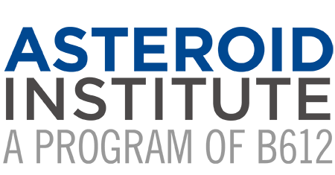

Schweickart Prize Was Announced to Recognize Contributions to the Field of Asteroid Defense

Launched to honor Apollo 9 astronaut Russell “Rusty” Schweickart, it recognizes
students, and early career individuals working towards planetary defense solutions

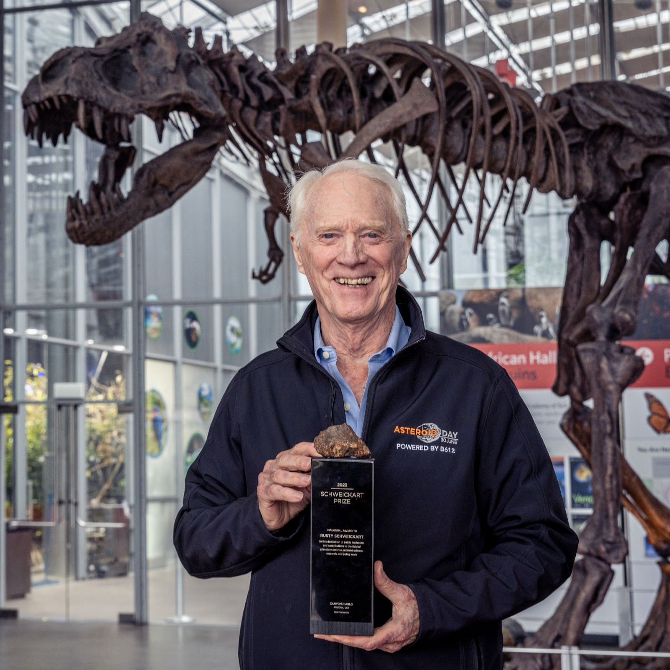
San Francisco, June 30, 2023 /PRnewswire/ – Today, on June 30th, International Asteroid Day, B612 Foundation announced the Schweickart Prize, named in honor of renowned Apollo 9 astronaut Rusty Schweickart, which will recognize individuals who have made exceptional contributions to planetary defense and advancing life's evolutionary journey. The prize acknowledges the significance of embracing our collective responsibility for safeguarding humanity's transition into the broader cosmos. “Through the Association of Space Explorers (ASE), we worked on the issue of planetary defense from asteroid impacts. Rusty Schweickart took a leadership role with the ASE to enable others to bring this global issue to the United Nations. This topic is now debated on a global stage as a result of Rusty’s commitment. This prize in Rusty’s honor is a fitting tribute to his lifetime of leadership,” said Dr. Franklin Chang-Díaz, NASA astronaut, CEO of Ad Astra Rocket Co, and NASA’s first Hispanic astronaut.
The Schweickart Prize emphasizes the need to address existential risks like asteroid impacts. “As citizens of Earth, we have to do everything in our power to preserve it and save it from all sources of danger. The Schweickart Prize encapsulates this concept and will be a beacon of achievement for all those working to prevent asteroid impacts here on Earth,” said Anousheh Ansari, CEO of XPRIZE, private space explorer and first Iranian astronaut.
The prize will be awarded annually to exceptional individuals, specifically undergraduate and graduate students and early career professionals actively involved in planetary defense. Their work will demonstrate notable progress in threat discovery, mitigation strategies, civil protection, public education, or responsible geopolitical decisions. “The Schweickart Prize will recognize a new generation of students who will contribute to future advancements in space exploration for the benefit of all life on Earth, particularly in the face of existential challenges like asteroid impacts,” said Nicole Stott, NASA astronaut, artist, co-founder of Space For Art Foundation, and first watercolor painter in space. The open call for Schweickart Prize nominations will be posted this October at Schweickartprize.org.
The future awardees will have achieved accomplishments, including facilitating international cooperation, addressing legal issues, stimulating student engagement, validating NEO deflection techniques, establishing public credibility, developing visual tools, or exploring innovative approaches to minimize NEO impacts. “The California Academy of Sciences stepped up as one of the inaugural supporters of Asteroid Day because we want our audiences to take an interest in understanding the risks and opportunities of asteroids. We are proud to support the Schweickart Prize, which we hope will increase interest in this topic and enable us to develop more visualization tools and techniques to enhance public understanding of planetary defense,” said Ryan Wyatt, Senior Director of Morrison Planetarium and Science Visualization, California Academy of Sciences.
Beginning in 2024, Schweickart Prize awardees will receive a cash prize of $10,000 USD and gain global exposure through a press campaign to acknowledge their achievements. The awardees will also receive a prestigious unique award with a museum-quality meteorite, symbolizing the existential nature of the prize's purpose.
“The Schweickart Prize Award Committee comprises representatives from renowned universities and organizations worldwide, specializing in astronomy, planetary science, aerospace, and space policy programs,” said Danica Remy, President of B612 Foundation and co-founder of Asteroid Day. Committee members representing the many facets of the planetary defense issue will play a vital role in the process. Committee members include Anousheh Ansari, astronaut, XPRIZE (USA); Dr. Richard Binzel, MIT (USA); Dr. Jeffrey Hoffman, astronaut, MIT (USA); Dr. Irmgard Marboe, University of Vienna (Austria); Dr. Patrick Michel, Lagrange Laboratory at the Côte d'Azur Observatory (France); Hong-Kyu Moon, Korea Astronomy and Space Science Institute (Korea); Oliver Morton, The Economist (UK); Dr. Soichi Noguchi, astronaut, Mirai Space Co. (Japan); Dorin Prunariu, cosmonaut, Asteroid Foundation (Luxembourg); Dr. Frans G. von der Dunk, University of Nebraska-Lincoln (USA) and other distinguished members to be added in the future. See SchweickartPrize.org for more information.
Founding Sponsors who have generously funded the first five years of the Schweickart Prize program include several anonymous donors, Anousheh Ansari, Barringer Crater Company, B612 Foundation, Future Ventures, Geoffrey Notkin, Jurvetson Family Foundation, Meteor Crater, Randy Schweickart and Michelle Heng, and Rusty B. Schweickart and Joanne Keys.
The Schweickart Prize launch ceremony and reception Friday, June 30, 2023, is generously funded by Lynmar Estate, the California Academy of Sciences, George & Loretta Whitesides, David Ramsey, Matthew Ramsey, Will & Anya Wright and Tito's Vodka.

About B612 Foundation and the Schweickart Prize
Since 2002, B612 Foundation has supported research and technologies to enable the economic development of space and enhance our understanding of the evolution of our solar system through its Asteroid Institute program and supporting educational programs, including Asteroid Day. Founding Circle and Asteroid Circle members and individual donors from 46 countries provide financial support for the work. For more information, visit B612foundation.org or follow on social: Twitter, Facebook.
The Schweickart Prize, a program of B612 Foundation, is an annual award that celebrates individuals who have contributed to planetary defense and the evolutionary future of life. It aims to recognize and stimulate advancements in critical areas of planetary defense, encouraging global cooperation and responsible decision-making. The prize is named after Russell “Rusty” Schweickart, renowned Apollo 9 astronaut, co-founder of the Association of Space Explorers and co-founder of B612 Foundation. For more information, visit Schweickartprize.org.

# # #
MEDIA CONTACT
Media Contact: Submit via Media Request Form or contact Joelle Byars +1 415-910-0662
Media Request Form

