Asteroid Institute Unveils Rapid Online Precovery Tool For Searching Multiple Astronomical Datasets in Minutes

Demonstrating a new era of software-driven asteroid discovery and tracking

San Francisco, August 1, 2023 /PRNewswire/ – Asteroid Institute, a program of B612 Foundation, announced today the release of a publicly available Precovery service that can both confirm and refine the orbits of asteroids by rapidly searching through a collection of astronomical data that has been curated and hosted on Google Cloud. The service, which runs on the Asteroid Discovery Analysis and Mapping (ADAM) platform and its unified observational dataset, can provide results in a matter of minutes for a task that typically takes astronomers days or months (if starting from scratch) to complete.

The utility of this ADAM::Precovery service is illustrated by three recent use cases. Earlier this week, Asteroid Institute scientists found a collection of previously unattributed images of the newly discovered Potentially Hazardous Asteroid (PHA) 2022 SF289 as found by the team at Vera C. Rubin Observatory. ADAM::Precovery was also used by the Institute to refine the orbits of 28 PHAs tracked on the NASA and ESA Risk Lists. Finally, the commercial company Karman+ has been working with Asteroid Institute to use precovery in finding observations of Near Earth Asteroids that could be potential targets for space missions. Discovering additional observations can play a significant role in refining the orbits of
these targets.

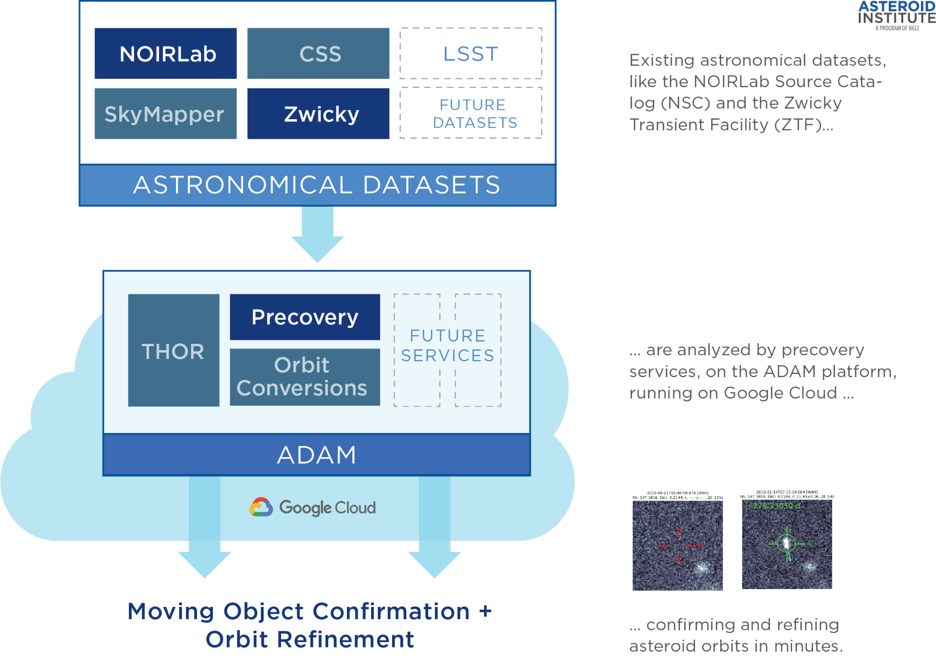

“Our Precovery service is now available for astronomers and space mission operators worldwide to query a number of astronomical datasets where they may discover previously unattributed points of light belonging to moving objects,” said Asteroid Institute Executive Director, Dr. Ed Lu. He continued, “These additional observations can be used to increase the orbital precision of these objects.” Precovery runs on the open-source ADAM astrodynamics platform using the computational and storage capabilities in Google Compute Engine, Google Cloud Storage, and Google Kubernetes Engine. The combined ADAM::Precovery service searches through the ADAM Unified Observational Dataset, which currently includes data from the Zwicky Transient Facility and NOIRLab Source Catalog (DECam and other telescopes). Additional surveys will be available in the near future.

“By smart and skillful usage of Google Cloud compute and storage systems, B612 has been able to extract the maximum possible information from existing astronomical data to identify unknown asteroids, improve our prediction of their orbits and estimate the probability of possible collisions with our planet,” said Massimo Mascaro, Technical Director in Google Cloud’s Office of the CTO. “Being able to scale to hundreds of machines quickly and on-demand, these astronomical computations are an indispensable capability for this team, allowing them to efficiently leverage resources and to perform computations that would not be possible otherwise. We strongly believe this cloud-based approach will ultimately be the determining factor in democratizing advanced computation in science, ultimately benefiting us all.”

The utility of this system was on display last week. Within minutes of being notified of its discovery in ATLAS survey data by the Rubin Observatory team, Asteroid Institute engineers recovered additional observations of newly identified potentially hazardous asteroid 2022 SF289 using ADAM's precovery tool. The eight new observations, all found in the data from the Zwicky Transient Facility, were previously unreported and included three predating the original discovery observation. "What blew our Solar System team away was the ease and speed with which ADAM::Precovery could do this," said Dr. Zeljko Ivezic, Director of the Rubin Observatory. "Previously, such a comprehensive, multi-survey, search would require days of manual work; with ADAM::Precovery we had the answer in minutes. It felt like Googling the imaged sky!"

The ADAM::Precovery service can be used by astronomers, space scientists, and space mission operators who are seeking to refine the orbits of objects in our solar system. "Many Near Earth Asteroids on the list of targets for our space missions have poorly known orbits, which is challenging for mission design. Precovery improves these, increasing the number of feasible mission targets." said Lauri Siltala, Asteroid Characterization Specialist at the commercial company Karman+.

The ADAM platform is continuously ingesting new survey data as well as performing nightly scans of the JPL and ESA Risk Lists to better refine the orbits of objects with a non-zero impact probability of hitting the earth. If any new objects have been added to either list, or any objects have had their orbits updated, a new precovery search is triggered. In the event that a new observation has been made available from an ongoing survey (such as ZTF), these observations are automatically ingested into ADAM's unified astronomical data storage format and are made available for precovery searches. Any findings by the Institute are then reported to the Minor Planet Center, the official body for observing and reporting on small-bodied objects, to update orbits of known asteroids.
“We are proud to be providing scalable tools to help astronomers and mission planners do their work more efficiently and effectively. Americans place monitoring asteroids on the top of the space agenda in last week's Pew survey, and that's what our ADAM platform enables,” said Danica Remy, President of B612 Foundation.
To use the ADAM::Precovery service and learn more about the platform and tools being developed visit https://b612.ai/platform/precovery
About B612 Foundation and Asteroid Institute

Asteroid Institute brings together scientists, researchers, and engineers to develop tools and technologies to understand, map, and navigate our solar system. A program of B612 Foundation, Asteroid Institute leverages advances in computer science, instrumentation, and astronomy to find and track asteroids. Since 2002, the foundation has supported research and technologies to enable the economic development of space and enhance our understanding of the evolution of our solar system in addition to supporting educational programs, including Asteroid Day and the new Schweickart Prize. Founding Circle and Asteroid Circle members, and individual donors from 46 countries provide financial support for the work. For more information, visit B612foundation.org or follow on social: Twitter, Facebook, YouTube, and LinkedIn

# # #

Media Contact
Colleen Fiaschetti
650-644-4539
Media Request Form

